Healthy Rides 2018 – Annual review
By Bruce Lynn, Healthy Rides Co-Ordinator, Southwark Cyclists
During 2018 we ran 51 rides with an average of 17 riders. Very similar to last year (see graph). The small overall fall was mostly due to the unusually cold start to the year. Numbers in January-March were down 31%, numbers from April to December were unchanged from 2017. Number of riders at Dulwich starts continued to be a bit lower than at other locations. The year-on-year drop of 27% was however mostly due to having winter rides from Dulwich in 2018. In 2017 Dulwich rides only began in April.
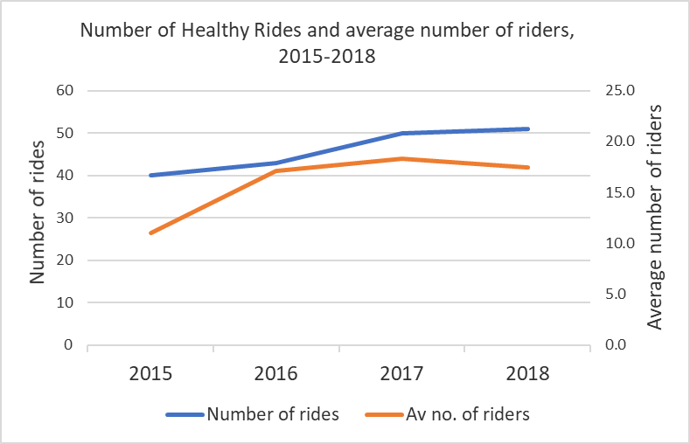
Two notable firsts in 2018. In August we met up with Bexley Cyclists at the Thames Barrier. The Bexley Healthy Rides began in 2018, initiated by Harry Clark. Harry had been on our rides and had led several, but in 2018 started similar rides in his home borough. In addition Harry still led several rides for us in 2018. The Bexley rides have been well supported and there were around 60 riders at the Thames Barrier for the joint picnic (see photo and also the video at https://youtu.be/0-vaVm2T3DQ . Late in the year we started 2 rides at the “Southwark Gateway Needle” close to London Bridge Station. This proved a popular venue with 30 riders on the first ride. Using this start location in the north west corner of the borough allowed us to extend the range of rides to Primrose Hill and Notting Hill.
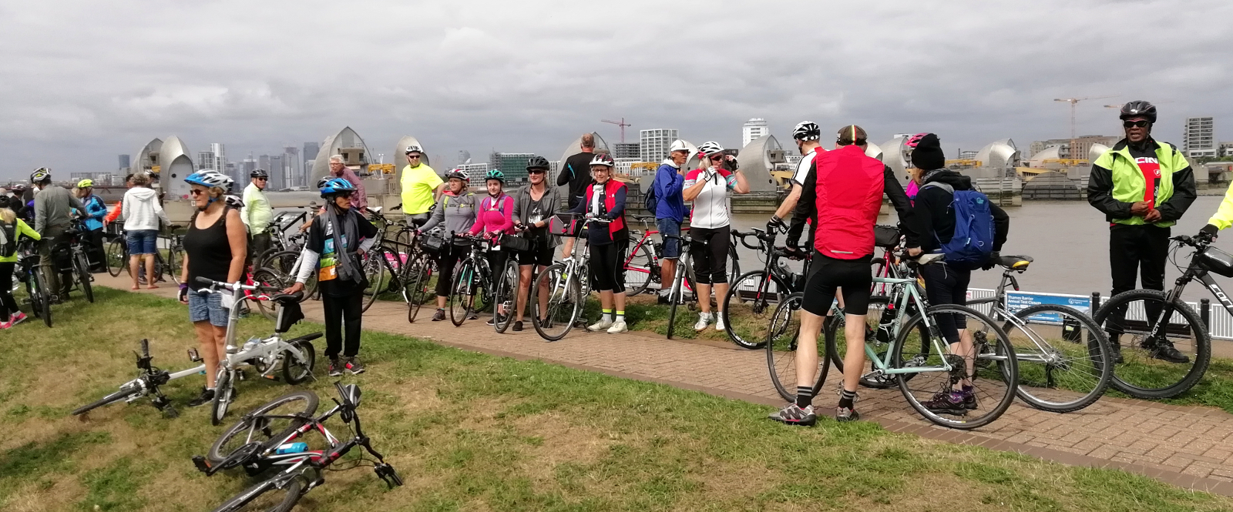
Southwark Cyclists could not run rides every Saturday without a lot of help, including from quite a few riders who do not live in Southwark. The usual big thankyou to David Senior who looked after the back of the group for almost all rides, and led some. And big thankyous to Jane, Amanda, Philippa, Werner, Harry and Charlie Cornwall who all led rides.

